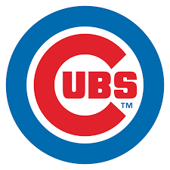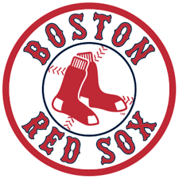

**DBC Wildcats!!!**

Project Objective: To see who has the most die hard fans between two historic baseball teams.

Teams selected: Chicago Cubs and Boston Red Sox

How will this be analyzed?

*Take all home games for 10 years for both teams.*

*Only count games where the temperature was 60 degrees or less and adding in the precipitation to identify the most fanatical fans.*

*Look at how many fans attended those home games versus ballpark capacity.*

*Plot them over ten years to see which teams has the most obsessive fans.*

Data: Baseball.reference.com, Wikipedia.org,

Darksky.com for weather.

Things we had to consider: The ball parks both changed seating capacity a lot over the ten year period.

Fenway park also has a different seating capacity for day and night games.

Wrigley field has standing room only areas, which allows it to have more fans than seats on some game days.

**All of these were taken into consideration and the winner is:**

Boston: 3960942



Chicago: 3461281

Wrigley Field had less night games per neighborhood restrictions.

Starting in 1988, Wrigley Field were allowed 18 night games, and today are allowed 43, 11 less than the league average of 54 in 2018.

Over the ten year period, Boston hosted 560 night games compared to 328 for the Cubs making a difference of 58.5% more night games at FenwayPark. This is the main reason Red Sox fans edged out the Cubs fans.